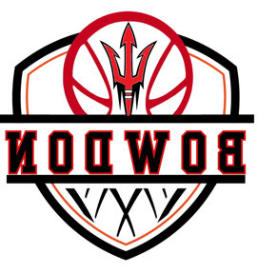
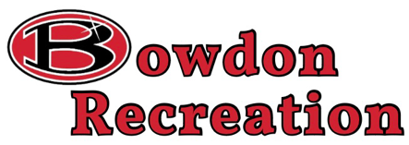
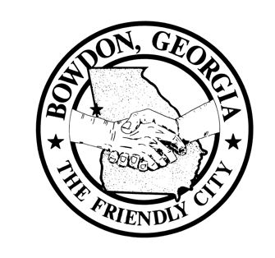
103 Barr Avenue
Bowdon, GA 30108

Telephone 770-258-8988
Email brd@bowdon.net
Brd.RecDesk.com

DIRECTOR
Allan Fordham

ATHLETIC COORDINATOR
Chris Webb

LEISURE COORDINATOR
Julie Smith

GYMNASTICS COORDINATOR
Candis Bramble

2024 GRPA State Basketball Tournament

Welcome from the Friendly City of Bowdon. We would like to wish you all the best of luck in the upcoming GRPA 14u Boys State Basketball Tournament. Included in this packet is contact information for local hotels, restaurants, and other businesses of possible interest during your trip. This will be our third year hosting this tournament and we continue to try to improve upon what we provide for you and your teams. We will be providing a hospitality room for coaches and other officials during the tournament.

As an added bonus this year we have a special day planned for Saturday. As you all know there is a waiting period required between the last semi-final game and the championship game. This year we have teamed with the Harlem Legends, and they will be putting on a Globetrotters type show during this period. The Harlem Legends are a team of retired Harlem Globetrotters, NBA players, as well as other professional players from a variety of sports. All teams and fans will be provided with a wrist band for to stay or be able to re-enter the gym to enjoy this event as well. We will be providing souvenirs from the tournament as well as from the Harlem Legends that will be available for purchase. Anyone arriving after 3:00 pm without a wrist band will be required to have or purchase a $20 ticket for this Harlem Legend event, which is a fundraising event as well for the Bowdon Recreation Department and will be allowed to stay for the State Championship Game immediately following this event. The purchase of a Harlem Legend event ticket will allow entry for the entire day Saturday.

We hope to be able to provide your teams, coaches, fans, and families with an enjoyable experience. If you have any questions, please feel free to contact us.

Allan Fordham
Bowdon Recreation Department Director
Cell- 770-550-3900

Hosted By: Bowdon Recreation Department

Event: Class C 14 & Under Boys

Dates: March 1-2, 2024

Game Site: Bowdon High School Gymnasium
616 Adamson St.
Bowdon, Ga, 30108

Contact Information: Allan Fordham
Email: Afordham@bowdon.net
Phone: (770) 550-3900

Entry Fee: $305.00 (Make check payable to Bowdon Recreation Department)

Officials: Georgia High School Officials – Scheduled by Southern Basketball Officials

Coaches Meeting/Roster Check in: Will be one hour before your first game. Players not checked in at roster check will not be allowed to play.

Jerseys: Matching jerseys w/ numbers, undershirts must be same color as jersey or white

Awards: 1st & 2nd Team trophies and 1st & 2nd Individual Awards

Admission: Adults $5.00 (18 years of age and older)
Children $2.00 (Under 18)
Adults 55 and over $2.00

After 2:00 pm on Saturday March 2, 2024, tickets for entry will be $20 which will include admission to the Harlem Legends Show as well as the State Championship Game.

2024 GRPA State Basketball Tournament
Lodging Information

Americas Best Value Inn & Suites Holiday Inn Express Cottage Hill Inn
1111 Bankhead Highway 1545 Highway 27 South 104 South Cottage Hill Road
Carrollton, GA 30117 Carrollton, GA 30117 Carrollton, GA 30117
770-830-1000 800-465-4329 770-838-0508

Courtyard by Marriott Quality Inn & Suites Holiday Inn Express & Suites 180 Barnes Avenue 1077 Alabama Ave. S 125 Hwy 27 Bypass (Exit 11)
Carrollton, GA 30117 Bremen, GA 30110 Bremen, GA 30110
678-664-5208 470-868-7717 770-537-3770

Hampton Inn
28 Price Creek Rd.
Bremen, GA 30110
770-537-9001

Local Restaurants, Dining, Shopping, & Entertainment

El Mezcal Mexican Restaurant Southern Lady Restaurant
108 City Hall Ave. 112 Shirley Ave.

Smokin’ Pig O’ Berry’s
409 W. College St. 139 City Hall Ave. Suite C

Wendy’s Jack’s Family Restaurant
139 E College St. 729 E. College St.

Subway Bowdon Coffee Roasters
192 Lovvorn Ave. 140 City Hall Ave. #C

Checker Berry Shoppe Antique Store Flicker & Flame Candle Co.
129 W. College St 114 W. College. St.

Brushstrokes Art Studio God’s Gym
112 W. College St. 139 City Hall Ave.

https://www.bowdon.net/mainstreet/

