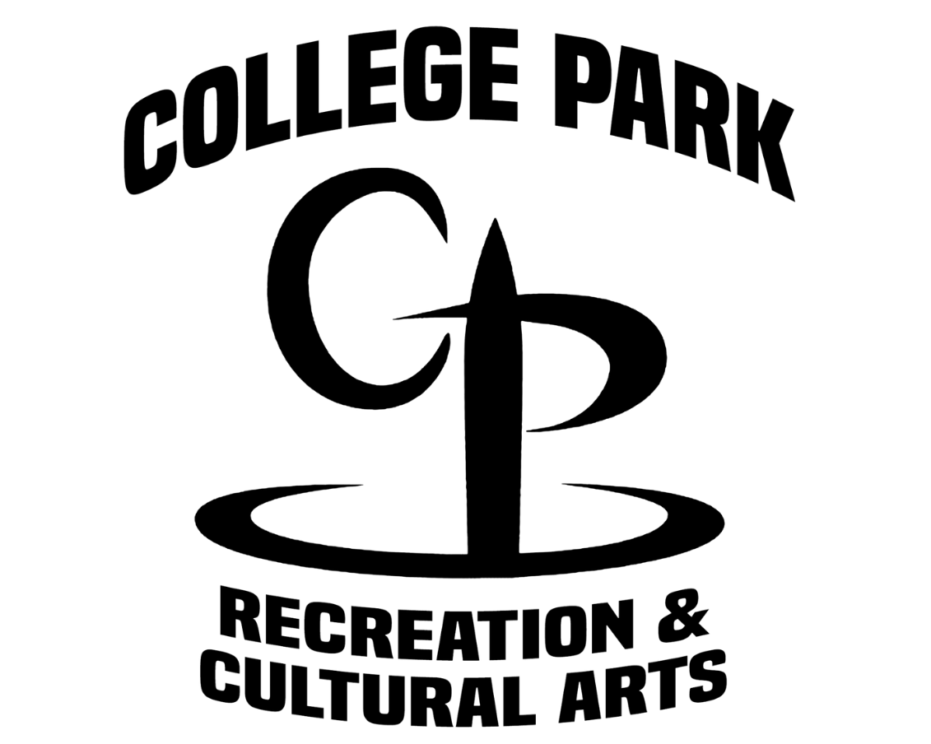
City of College Park Recreation Department
P.O. Box 87137 – College Park, GA 30337
Brady Center (404) 669-3776
Conley Center (404) 669-3773
Tracey Wyatt Center (404) 669-9206

Dear Basketball Team:

On behalf of the City of College Park and the College Park Recreation Department, I welcome each team and its fans to the 2024 G.R.P.A. State 12 & Under Boys Basketball Tournament at the Tracey Wyatt Recreation Center 2300 Godby Rd College Park, GA 30349.

For your information, alcoholic beverages are prohibited from inside or outside of the gymnasium, including the parking lot. For your safety, there will be law enforcement officers on duty at all times.

If we can be of any assistance to your team, please let us know.

Good luck to all of you!

Sincerely,

City of College Park Recreation Department

Kirkland Arnold
karnold@collegeparkga.com
Boys’ Basketball Coordinator
Cell: 470-469-8215
Office: 404-669-3773

2024 GRPA 12 & UNDER BOYS
STATE BASKETBALL TOURNAMENT
MARCH 1-2, 2024
COLLEGE PARK, GEORGIA

Gym Location: Tracey Wyatt Recreation Center

Entry Fee: Pool Play/Single Elimination Tournament: $305.00 Make check payable to:
CITY OF COLLEGE PARK

Officials: Two (2) G.H.S.A. approved officials will be used at all games.

Awards: Team trophies awarded to first and second place, and individual awards for first and second place.

Rules: G.R.P.A. Manual, pages 66-69 and G.H.S.A.

Coaches: No more than 3 coaches. Coaches meeting 1 hour prior to pool play game.

Uniforms: Uniforms shall consist of a team shirt or jersey with numbers on the front and back, identical in style and color with other members of the same team. The under shirt must be the same color if used and shall not have frayed or ragged edges. Players cannot play unless they meet the uniform requirements.

Uniform Numbers: 0, 00, 1-5, 10-15, 20-25, 30-35, 40-45, and 50-55. The numbers 0 and 00 cannot be used on the same team.

Forfeit: Game time is forfeit time.

Admission Fee: No Charge

Concession: A concession will be available at gym.

Hospitality Room: Will be available for Coaches and Recreation Department Staff

Security: City of College Park Police Officers will be present at all times.

Tournament Kirkland Arnold
Director Cell: 470-469-8215
Office: 404-669-3773
Email: karnold@collegeparkga.com

2024 GRPA STATE 12 & UNDER BOYS
BASKETBALL TOURNAMENT
MARCH 1-2, 2024
COLLEGE PARK, GEORGIA

Coach’s Agenda

- Tournament will be governed by the current rules and regulations of the GHSA Constitution and GRPA Athletic Manual.

- Game time will be forfeit time. There will be NO GRACE PERIOD.

- Good sportsmanship is expected from all players, coaches, and spectators. Please remember that you are not only representing your team you play for but your recreation department as well. Any negative cheering or hollering may result in a warning and/or removal from the site, whether it is for or against your team.

- Any player or coach ejected from a game for unsportsmanlike conduct will be suspended for one game, in addition to the game from which ejected.

- Make sure you read the bracket carefully for your next game time.

If you have further instructions or questions, please feel free to contact the Tournament Director.

Kirkland Arnold
Tournament Director
Cell: 470-469-8215
Restaurants

Local Restaurants (Main Street Downtown College Park)

Virgil’s Gullah Kitchen
Hattie Marie’s Texas BBQ
Nouveau
Johnny’s Chicken and Waffles
The Real Milk and Honey

Chain Restaurants

Olive Garden
TGI Friday’s
Ruby Tuesdays
Longhorn
Kiku Japanese Steakhouse
Old Lady Gang
The Juicy Crab
Red Lobster
Nancy’s Pizza

Fast Food Options
Burger King
Chipotle
Chick Fil-A
Five Guy
KFC
McDonalds
Moe’s
Wendy’s
Zaxby’s

HOTEL OPTIONS

Fairfield Inn & Suites
2020 Sullivan Road
College Park, GA 30337
770-994-3666

Country Inn and Suites
5100 W Fayetteville Road
College Park, GA 30349
678-369-9165

Comfort Inn Atlanta- Airport
1888 Sullivan Road
College Park, GA 30337
678-552-1507

Embassy Suites
4700 Southport Road
College Park, GA 30337
404-767-1988

Courtyard By Marriott
2050 Sullivan Road
College Park, GA 30337
770-997-2220

Home2Suites By Hilton
3433 Bobby Brown Parkway
Atlanta, GA 30344
404-767-5877

Hampton Inn & Suites
3450 Bobby Brown Parkway
Atlanta, GA 30344
404-767-9300

Homewood Suites By Hilton
3405 Bobby Brown Parkway
Atlanta, GA 30344
404-554-9300

Holiday Inn & Suites Atlanta Airport
1380 Virginia Ave
Atlanta, GA 30344
404-305-9990

