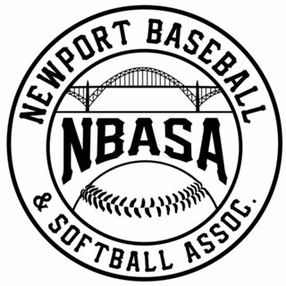
2019 END OF SEASON TOURNAMENT

ROOKIES RULES

- All games five innings. No new inning will start after 1 hour 15 minutes. In case of tie, team up to bat will put last out on second base and play out inning. Higher seed is home team.
- Ten run mercy rule in effect after four innings. Five run limit innings 1-4, unlimited last inning.

- 60-foot bases, 38-foot pitching machine set at 38 MPH.

- Standard baseball will be used (no safety balls). Coaches will pitch to their own team.
- No leading off, No stealing on the pitch. First offense warning. Next offense runner is out.
- Each team will bat entire roster and all players must play two consecutive defensive innings.
- All bats must be JBO approved. No bunting allowed. No metal cleats.
- The pitcher must wear a batting helmet (cage style mandatory). One foot must be in the pitching circle when the pitch is delivered. Helmets must be worn while batting and running the bases.

- Safety slide rule on close plays is in effect--failure to slide when there is a play is an out.

- Batted ball that hits the pitching machine is a dead ball single. Runners on base advance one base. Batter gets first base.

- Ball remains live only after a hit as long as it is in the field of play until the pitcher has it in possession inside the pitcher’s circle (at least one foot in the circle).

- Batter is out after 3rd strike or 5th pitch (unlimited foul balls).

- Half way rule in effect. If base runner has not crossed halfway point to the next base when the play is declared dead, runner must go back to last base occupied.
- Coaches are responsible for their players/fans/parents. 1st offense warning, 2nd offense forfeit. Please show good sportsmanship.

